**Project 2 – Implementing a truth table to drive a 7-segment display**

Task: Drive a 7-segment display for digits 0 – 9 in response to Monitor input.

Procedure: The project contains the following steps:

* Convert digits to binary-coded decimal values.
* Implement an efficient truth table that displays digits on 7-segment display.
* Compose difference equation for each segment using function
* Connect 7-segment display to UNO.
* Display digit entered in Monitor on 7-segment display

Truth Table

|  |  |  |  |  |  |  |  |  |  |  |  |  |
| --- | --- | --- | --- | --- | --- | --- | --- | --- | --- | --- | --- | --- |
| Digit | b3 | b2 | b1 | b0 |  | a | b | c | d | e | f | g |
| 0 | 0 | 0 | 0 | 0 |  | 1 | 1 | 1 | 1 | 1 | 1 | 0 |
| 1 | 0 | 0 | 0 | 1 |  | 0 | 1 | 1 | 0 | 0 | 0 | 0 |
| 2 | 0 | 0 | 1 | 0 |  | 1 | 1 | 0 | 1 | 1 | 0 | 1 |
| 3 | 0 | 0 | 1 | 1 |  | 1 | 1 | 1 | 1 | 0 | 0 | 1 |
| 4 | 0 | 1 | 0 | 0 |  | 0 | 1 | 1 | 0 | 0 | 1 | 1 |
| 5 | 0 | 1 | 0 | 1 |  | 1 | 0 | 1 | 1 | 0 | 1 | 1 |
| 6 | 0 | 1 | 1 | 0 |  | 1 | 0 | 1 | 1 | 1 | 1 | 1 |
| 7 | 0 | 1 | 1 | 1 |  | 1 | 1 | 1 | 0 | 0 | 0 | 0 |
| 8 | 1 | 0 | 0 | 0 |  | 1 | 1 | 1 | 1 | 1 | 1 | 1 |
| 9 | 1 | 0 | 0 | 1 |  | 1 | 1 | 1 | 1 | 0 | 1 | 1 |

|  |
| --- |
| a= b1 + b3 + (b2*b0) + (~b2*~b0) |
| b= ~b2 + (~b1*~b0) + (b1*b0) |
| c= ~b1 + b0 + b2 |
| d= b3 + (b1*~b0) + (~b2*b1) + (~b2*~b0) + (b2*~b1*b0) |
| e= (b1*~b0) + (~b2*~b0) |
| f= b3 + (~b1*~b0) + (b2*~b1) + (b2*~b0) |
| g= b3 + (b1*~b0) + (b2*~b1) + (~b2*b1) |

**Circuit diagrams -** Sketch circuit showing connection of 7-segment display to UNO pins, labeled with pin#, function (IN, OUT, ADC, PWM, …), 5V, and GRD. Neatness counts.

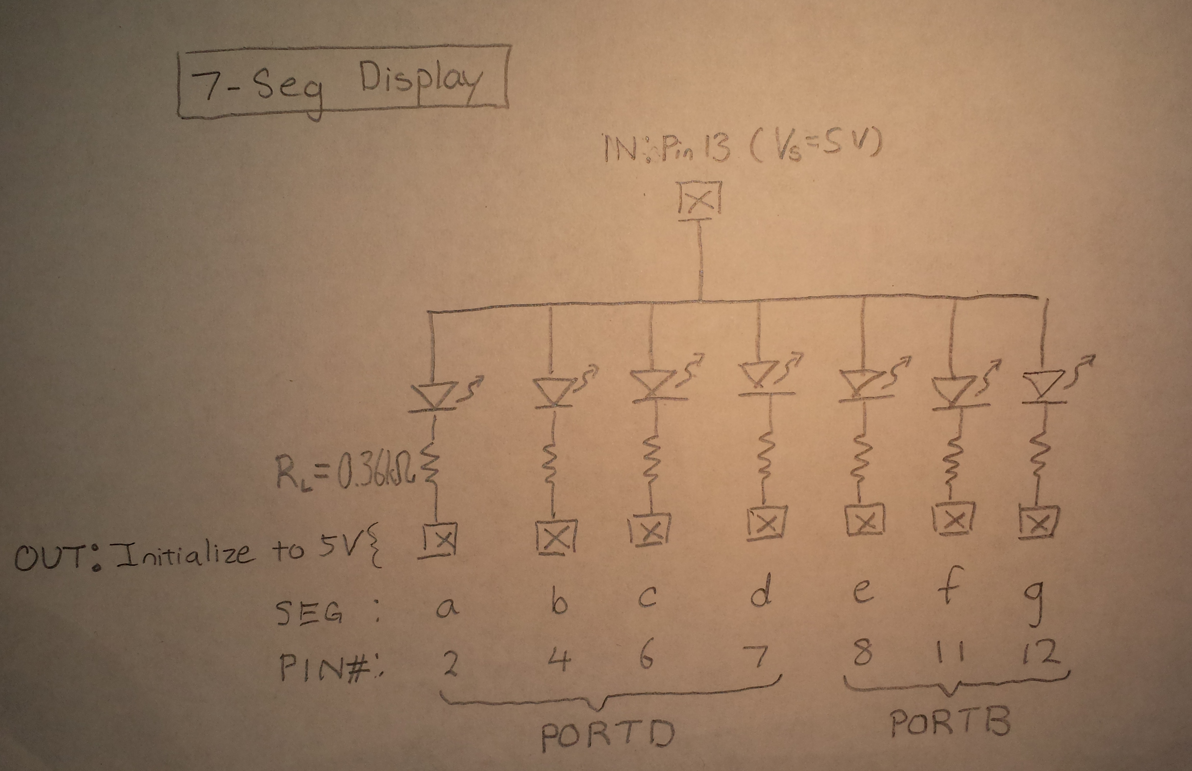

**Programs –**

**P02h – Hobbyist Commands**

**P02r – Digital I/O register commands.**

**Questions**:

1. Compute the current through each LED with 370Ω and 5V supply with VLED=2V..

I = V/R = 3/370 = 8.11 mA

1. How does 7-segment display change if only one resistor is used on the 5V supply?

The display will not work because the current is too low.

* 1. Compute current if 3 LEDs are lit.

I = V/R/3 = (3/370)/3 = 2.70 mA per diode

* 1. Compute current of 7 LEDs are lit.

I = V/R/7 = (3/370)/7 = 1.16 mA per diode